**Project Design Phase-II**

**Data Flow Diagram &User Stories**

|  |  |
| --- | --- |
| Date | 28 October 2022 |
| Team ID | PNT2022TMID34173 |
| Project Name | A Novel Method For Handwritten Digit Recognition System |
| Maximum Marks | 4 Marks |

**Data Flow Diagrams:**

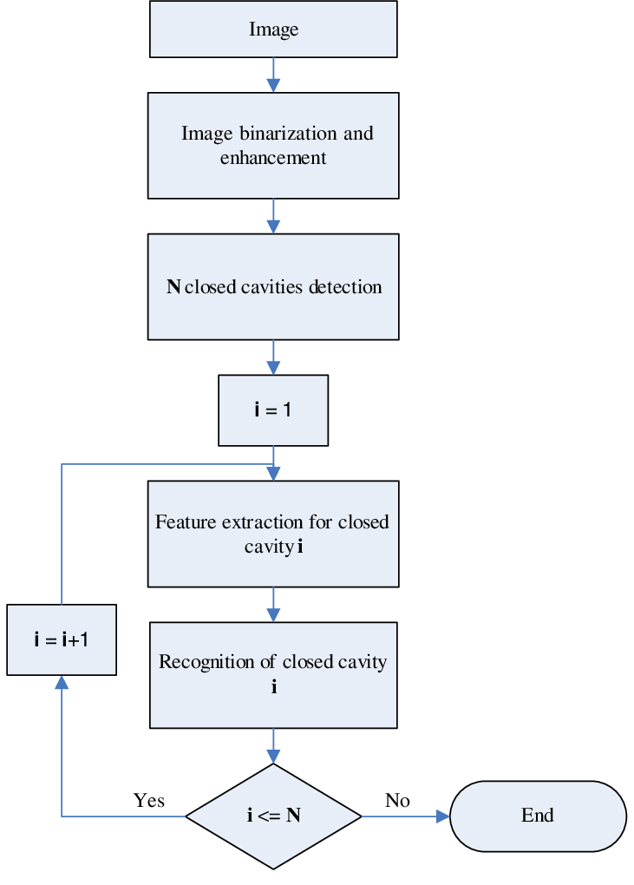

**User Stories**

| **User Type** | **Functional Requirement (Epic)** | **User Story Number** | **User Story / Task** | **Acceptance criteria** | **Priority** | **Release** |
| --- | --- | --- | --- | --- | --- | --- |
| Customer (Mobile user) | Pre-processing steps | USN-1 | As a user, I can collect digit data base | I can import the libraries | High | Sprint-1 |
|  |  | USN-2 | As a user, I will pre-processing the collected data | I can load the data set | High | Sprint-1 |
|  |  | USN-3 | As a user, I can extract the features from data | I can import all the modules for train the model | High | Sprint-2 |
|  |  | USN-4 | As a user, I can recognize the digit from data | I can recognize the digit present in the data | High | Sprint-2 |
|  | Features Extraction | USN-5 | As a user, I can extract the features from the import data | I can extract the hand written digit | High | Sprint-1 |
|  | Classification and Verification | USN-1 | As a user, I can classified and verified the data set | I can verify the character digit | High | Sprint-2 |
| Customer (Web user) | Usage | USN-1 | User can view the web page and get the information | I can view the data given by the device | High | Sprint-3 |
| Customer | Working | USN-1 | User can recognize the human handwritten source | It can be used in postal mail sorting | High | Sprint-3 |
|  |  | USN-2 | User can convert the handwriting digit into machine readable formats | It can be used in bank check processing | High | Sprint-4 |
| Customer care Executive | Action | USN-1 | User solve the problem when some faces any usage issues | I can solve the issues when some one fails to understanding the procedure | High | Sprint-4 |
| Administration | Administration | USN-1 | User can store the wide range of handwritting | I can store the gained handwritten digits | High | Sprint-4 |
|  |  |  |  |  |  |  |